**OOP (C++ )**

1. Format for **cout** **cout**  **<<**  **“message ”** **<<** endl;
2. Declaring variables **int** variable_name; or **float** variable_name or **char** variable_name.
3. Format for **cin**; **cin** >> variable_name;
4. Performing calculations ;

**Result_variable**  **=** **variable_1** **+** **variable2** e.g. **c = a + b;**

5. Key C++ constructs include ( **cout, cin**, declaring variables, performing calculations, the **if** statement using the format below using relational operators **(==, >, <, !=, <=, >=)** and the symbols used to combine more than one condition (&& **used for** AND), ( **|| used for OR). Note**  **== is used to represent equal and**  **!= is used to represent not equal to**)

(a) **if** **(**student_mark >= 80)

**{cout << “** Distinction Grade **“ << endl;}**

**6. Write a C++ program that tests a Leaving Cert Ordinary level result entered by the user that displays an appropriate message e.g “Grade O1” , “Grade 02” etc. Save the project as LCResults**

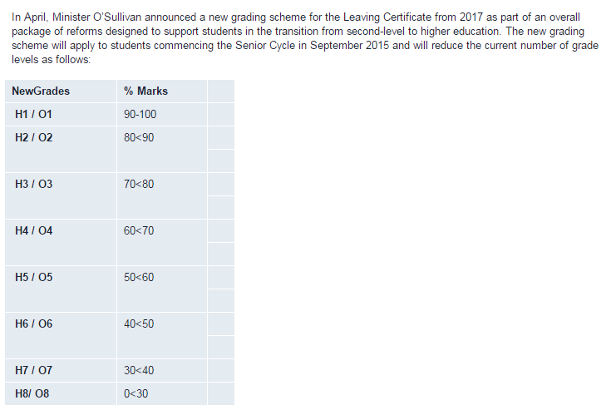

< 30 = O8

>=90 = O1

>=30 && <40 = O7

>=40 && <50 = O6

>=50 && <60 = O5

>=60 && <70 = O4

>=70 && <80 = O3

>=80 && <90 = O2

(b) **The format of the for loop that is used to repeat code is as follows**

For(int i=0; i<3; i++)

**{**Code to be executed if condition(s) are met. **}**

(c) **The format of the** while  **loop that is used to repeat code is as follows**

**Int n = 4;**

**While (n>0) {Program code to be repeated ;**

**n—**

**}**

Add a counter to allocate points and then repeat ( using for loop ) for 2 students.

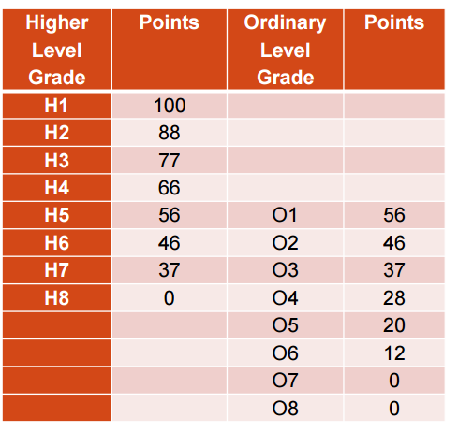

**7**.

' Arrays are very useful for storing data in an organised way

' where it can be easily retrieved during processing

' Data is stored in variables as follows A(1), A(2), A(3) etc"

'These are referred to as subscripted variables. In the example of a 1D Array below I is a counter which starts at 0 and is increased every time a result is entered by the user. The loop is created and the subscript added by using the **goto** statement and a label **start:** 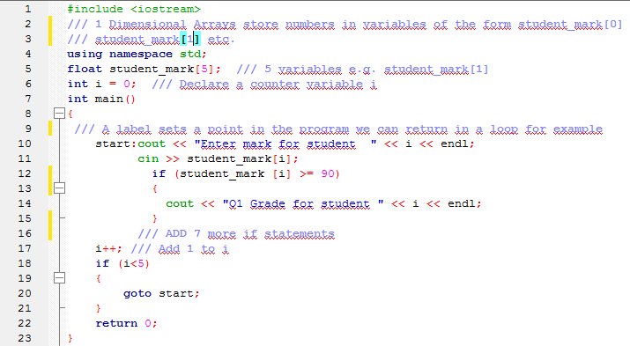

**A one dimensional array (using a for loop)**can store the hours worked for **3 employees** in **hours[0]**, **hours[1]** and **hours[2]**. First employee hours are stored in hours[0], second employee hours are stored in hours[1], second employee hours are stored in hours[2]. Declaring an array is done as follows on lines 12 & 15 . 



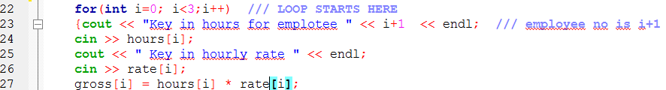 

**The loop is indicated above. On the first loop I =0, second loop i=1 and third loop i=2**

8. **Data types e.g. char, short, long, int, float, double**

Each keyboard character can be represented by it’s ASCII code ranging from

ASCII(0) to ASCII(255) for example ASCII (49) = 1, ASCII (65) = A, ASCII (97) = a,

**char** variables can store one keyboard character e.g 0,1,2,3,4,5,6,7,8,9 or A,B,C,D or a,b,c,d

short, int, long, float, double and long double variable types are used to store numbers.as follows

**unsigned short** can store integer values from 0 to 65535 16 bits

**signed short** can store integer values from -32768 to 32767 short & signed short, 16 bits

**unsigned int** can store integer values from 0 to 4294967295 unsigned int; 32 bits

**signed int** can store integer values from -2147483648 to 2147483647 int & signed int ; 32 bits

**unsigned long** can store integer values from 0 to 4294967295; 32 bits

**signed long** can store integer values from -2147483648 to 2147483647 long int & signed long int; 32 bits

**float** can store values (with a decimal amount) from 3.4 X 10^-38 to 3.4^+38; 32 bits

**double** can store values (with a decimal amount) from 1.7 X 10^-308 to 1.7^+308; 32 bits

**long double** can store values (with a decimal amount) from 1.2 X 10^-4932 to 1.2^+4932; 32 bits

**bool** can store values from **true** or **false**

**Data type conversion take place when a variable of one type is moved to a variable of a different type e.g storing a short variable type in an int variable type.**

**C++ automatically converts the data in the lower data types**

**char < short < int < int <= long < float < double**

**to the higher type which is called promotion without loss of data**

1 D Arrays for OOP A2